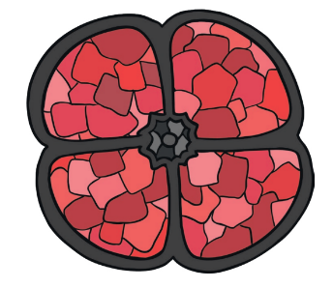
Home Learning Oak Class Wednesday 1st November

For your home learning this week I would like you to commemorate Remembrance Day by reading this poem until you are fluent.

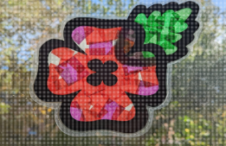
Please could you also make your own poppy to display in the classroom. You can decide how you do it and try and choose a different way to what you have done before. Below are some ideas, if you need any help just ask.
- Paint a poppy
- Make a hand print poppy
- Collage a poppy
- Make a sun-catcher poppy
- Make a stained-glass poppy
Or any idea you think of. put some templates in your book in case you need them and then bring it back to school and we will display them in our classroom.
Please hand it in by Tuesday 7th November

