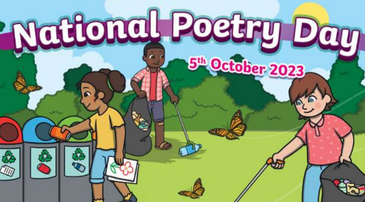
Home Learning Oak Class Wednesday 27th September
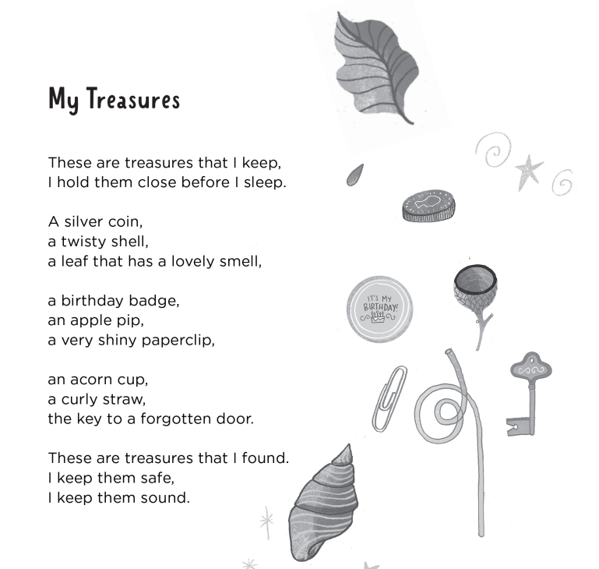
Next week Oak Class are going to be celebrating poetry for National Poetry day. We are going to have a week of reading, talking about, performing, writing our own and make art around our favourite poems. The theme for our poetry week is going to be ‘My Treasures’. For your home learning this week, practice reading this poem, in a loud voice, a quiet voice, a musical voice…
Afterwards, think about what your special things are.
Make a list of your special things. Draw them. Why are they special to you?
Then bring one special thing in on Thursday 5th October for National Poetry day!
Have fun!
Please hand it in on Tuesday 3rd October

