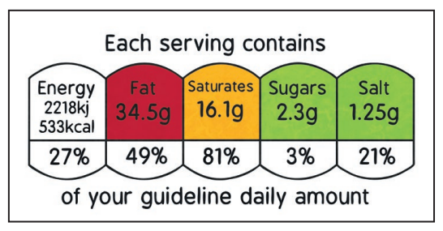
Willow Class Homework- Science; Investigating Food Labels Date- 6/10/23

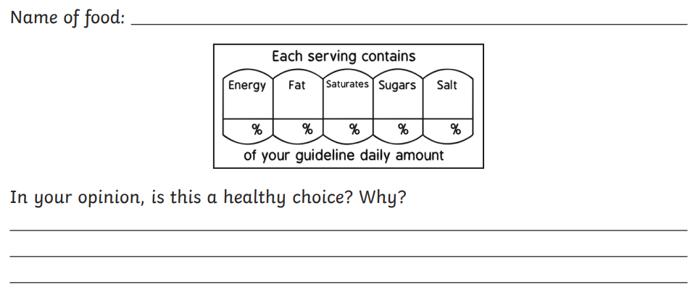
In science, this week, we have been exploring the ‘traffic light’ system on the front of food packages. These labels are supposed to help us make healthy choices. For your homework, I would like you to investigate some food labels for yourself and record the information they give you below. Remember to colour in the ‘traffic light’!

