Willow Class Homework- English; Similes (Year 2) Date- 22/9/23
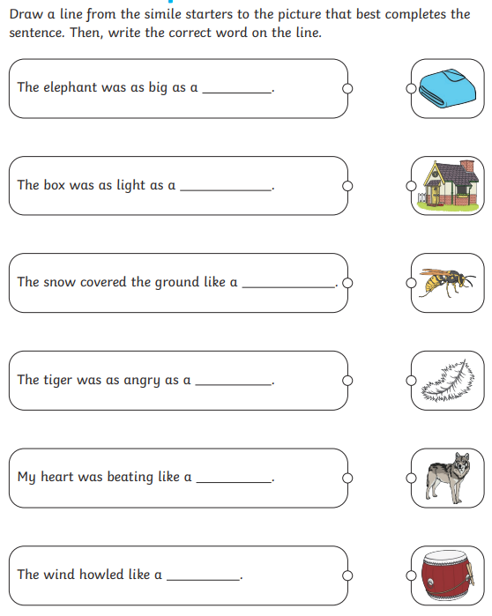
A simile is a way of describing something by comparing it to something else, using ‘like’ or ‘as’.
Challenge; Write your own sentence with a simile using ‘like’ or ‘as’ to describe and compare something.
………………………………………………………………………………………………………………………………………………………………..

