Willow Class Homework- Yr 2 & 3 Design and Make a Living Garden’. Date set- 14/7/23 Date due in- ON FRIDAY 21st JULY
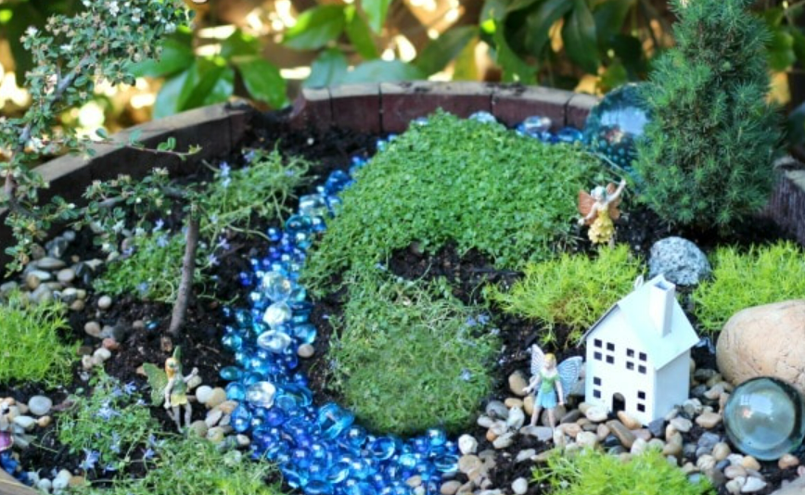
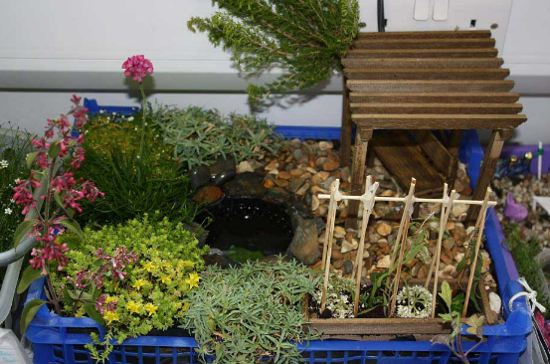
This week’s homework is OPTIONAL for any children who would like to do it. The homework is to design and make a ‘Living Garden’ which may be chosen to be entered into The Box Flower Show, held on Saturday 22nd July. The garden needs to be roughly the size of an ice cream tub (max size 2 litres) and obviously should contain some rooted plants. Other than that you can let your imagination run wild! However, please do discourage children from including precious toys as sometimes these go missing! Children do not need to record anything in their homework books but should bring their gardens to school ON FRIDAY 21st JULY. Have fun!

Willow Class Homework- Yr 2 & 3 Design and Make a Living Garden’. Date set- 14/7/23 Date due in- ON FRIDAY 21st JULY
This week’s homework is OPTIONAL for any children who would like to do it. The homework is to design and make a ‘Living Garden’ which may be chosen to be entered into The Box Flower Show, held on Saturday 22nd July. The garden needs to be roughly the size of an ice cream tub (max size 2 litres) and obviously should contain some rooted plants. Other than that you can let your imagination run wild! However, please do discourage children from including precious toys as sometimes these go missing! Children do not need to record anything in their homework books but should bring their gardens to school ON FRIDAY 21st JULY. Have fun!

