Willow Class Homework- English; Similes (2) Date- 9/6/23
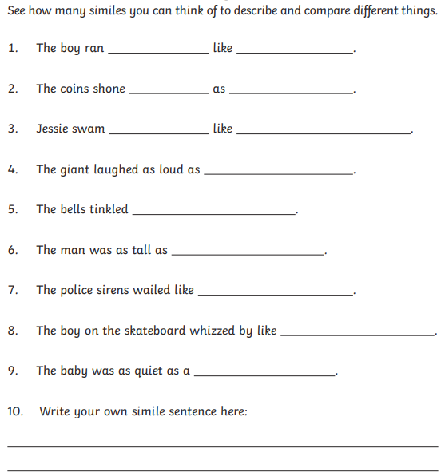
A simile is a way of describing something by comparing it to something else, using ‘like’ or ‘as’.

In ‘The Last Garden’ by Rachel Ip, that we are exploring in our English lessons, there is lots of description to describe the war torn city and Zara’s garden. Can you complete the following ‘simile kebab’ for something in either the city or garden?


