Willow Class Homework- English; Similes (3) Date- 9/6/23
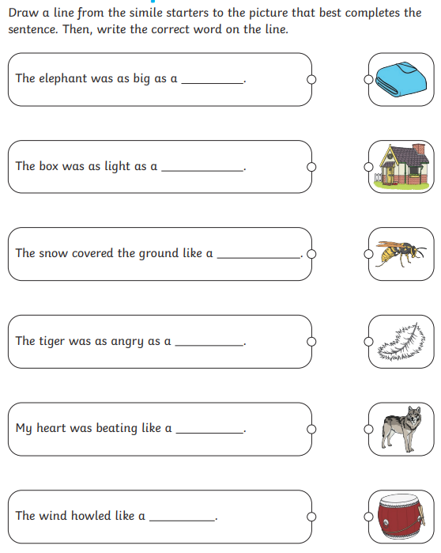
A simile is a way of describing something by comparing it to something else, using ‘like’ or ‘as’.

