
Home Learning Oak Class Wednesday 8th March
Over the next couple of weeks, we will be looking at the artwork of William Morris. For your home learning can you find out a little about him and either draw him or recreate one of his pieces of art like his tulips below.
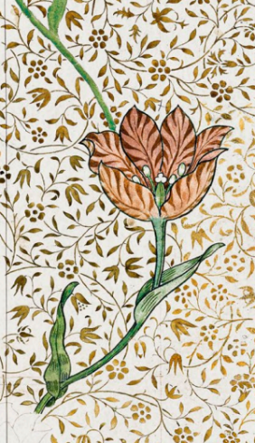
Please hand it in on Tuesday 14th March
You might think about:
When was he born and when did he die?
What did he train as?
What did he do?
Why was he a ‘superhero’?

