Willow class homework- English Date- 6/1/23
L. O. To identify and use fronted adverbials.
This week, in English, we have been learning to identify, use and correctly punctuate fronted adverbials. An adverbial is a word or phrase that has been used like an adverb to add detail or further information to a verb. Adverbials are used to explain how, where or when something happened; they are like adverbs made up of more than one word.

Read the information text below about the discovery of Tutankhamun’s tomb. Use a coloured pencil or highlighter to underline or highlight the fronted adverbials in the text.
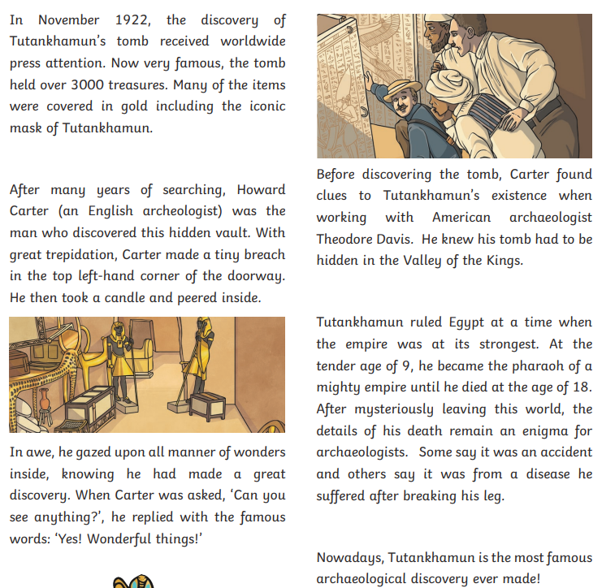

Each of the sentences below contains a fronted adverbial; however, this should be separated from the main clause with a comma. Read the sentences carefully and add a comma after each fronted adverbial.

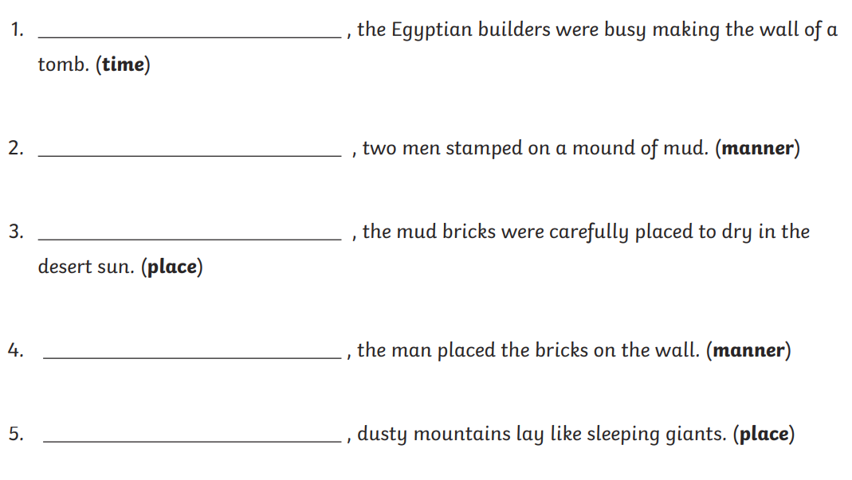
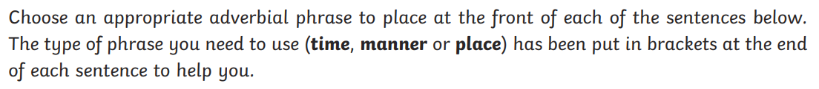
Challenge;

