Willow class homework- English Date- 6/1/23
L. O. To know the correct punctuation for different sentence types.
This week, in English, we have been learning to identify and correctly punctuate different types of sentences using either a full stop (.), exclamation mark (!) or question mark (?). Read the following sentences carefully and add the correct punctuation into the box(es).
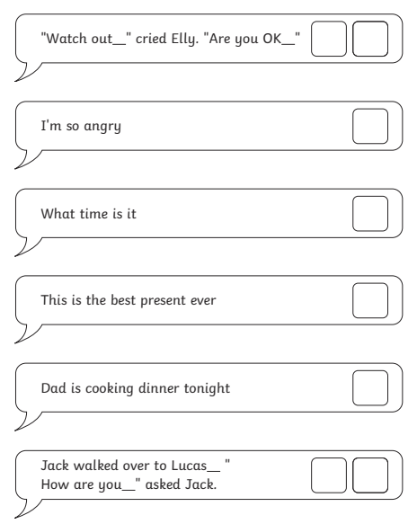

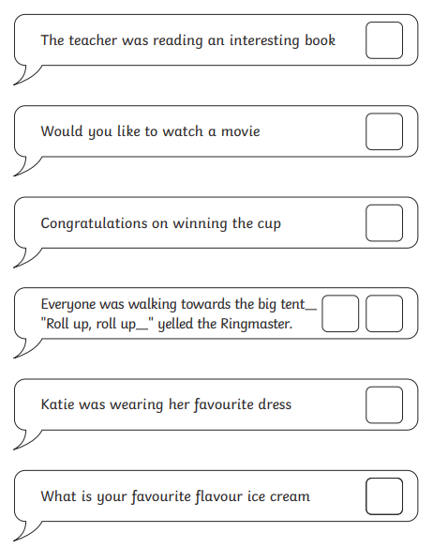
Challenge;
Write 3 different sentences; one that is punctuated with a full stop, one that is punctuated with an exclamation mark and one that needs a question mark.

