Willow class homework- ‘Little Amal and the Long Walk Nativity’ Date- 25/11/22
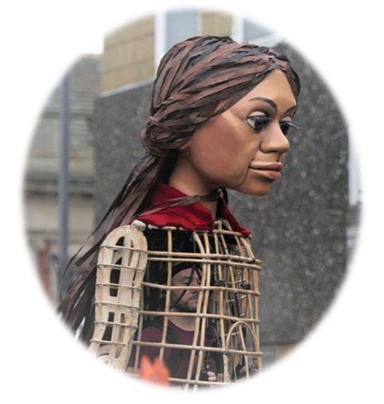
With Christmas rapidly approaching, the children are all busy practising for this year’s Nativity production of ‘Little Amal and the Long Walk’.
For homework this week, please encourage your child(ren) to keep practising the words for both their individual speaking/singing parts (year 2 children) and singing parts (year 3 children).
Year 2 children have already been given their own copy of the script. Please find enclosed the words for the Nativity songs.
Thank you for your support with this,
Tamsin Iacono

Willow class homework- ‘Little Amal and the Long Walk Nativity’ Date- 25/11/22
With Christmas rapidly approaching, the children are all busy practising for this year’s Nativity production of ‘Little Amal and the Long Walk’.
For homework this week, please encourage your child(ren) to keep practising the words for both their individual speaking/singing parts (year 2 children) and singing parts (year 3 children).
Year 2 children have already been given their own copy of the script. Please find enclosed the words for the Nativity songs.
Thank you for your support with this,
Tamsin Iacono

