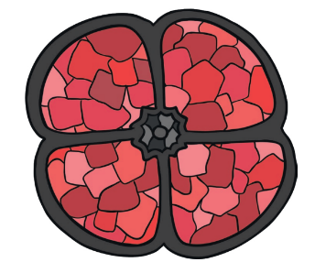
Home Learning Oak Class Wednesday 9th November

For your home learning this week I would like you to commemorate Remembrance Day by making your own poppy. You could:
- Paint a poppy
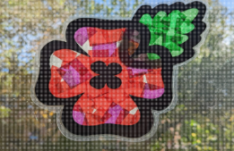
- Make a hand print poppy
- Collage a poppy
- Make a sun-catcher poppy
- Make a stained-glass poppy
Or any idea you think of. I have put some templates in your book in case you need them and then bring it back to school and we will display them in our classroom.
Please hand it in by Tuesday 15th November

