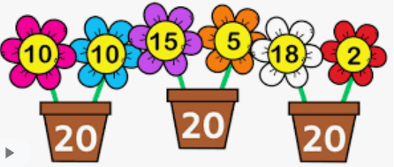
Home Learning
Oak Class Wednesday 12th October:

This week I would like you to practise your maths skills with quick mental recall. I would like you to work through the addition and subtraction facts and if you like add an extra challenge by timing yourself. To help warm you up you might have ago at Numbots first. Then go for it! If you do time yourself, record your time so that next time we do it you can try and beat it.
Please return your book by Tuesday 18th October.
Have fun!

Home Learning
Oak Class Wednesday 12th October:

This week I would like you to practise your maths skills with quick mental recall. I would like you to work through the addition and subtraction facts and if you like add an extra challenge by timing yourself. To help warm you up you might have ago at Numbots first. Then go for it! If you do time yourself, record your time so that next time we do it you can try and beat it.
Please return your book by Tuesday 18th October.
Have fun!

