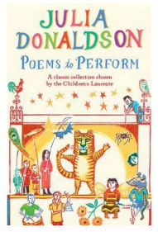
Home Learning Oak Class Wednesday 5th October: Let’s Celebrate National Poetry Day
To help celebrate National Poetry Day on Thursday 6th October, practice reading and sharing your favourite poems and if you like bring them to school to share. Read this poem by Julia Donaldson and then do one or more of the activities below.
You could:
Watch Julia Donaldson perform it on the CLPE website:
Question Time | Centre for Literacy in Primary Education (clpe.org.uk)
Practice reading it over and over with good expression.
Learn some of the verses to recite.
Draw pictures to go with the poem.
Write your own poem using questions and a question mark.
Choose any subject – e.g. birds
Ask lots of questions.
You could even try and make it rhyme!
Have fun!

__________________________________________________________________________________

__________________________________________________________________________________

__________________________________________________________________________________

___________________________________________________________________________________

___________________________________________________________________________________

___________________________________________________________________________________
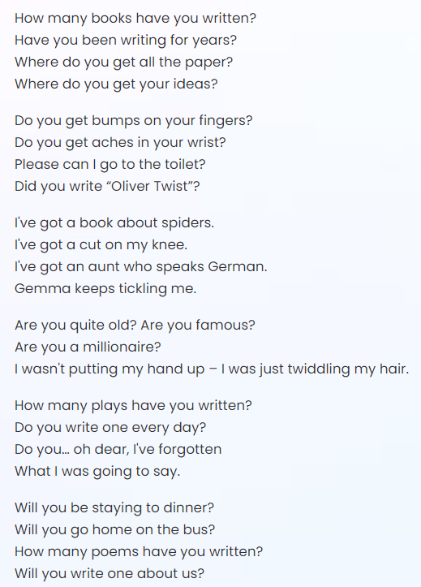

Please hand it in on Tuesday 11th October

